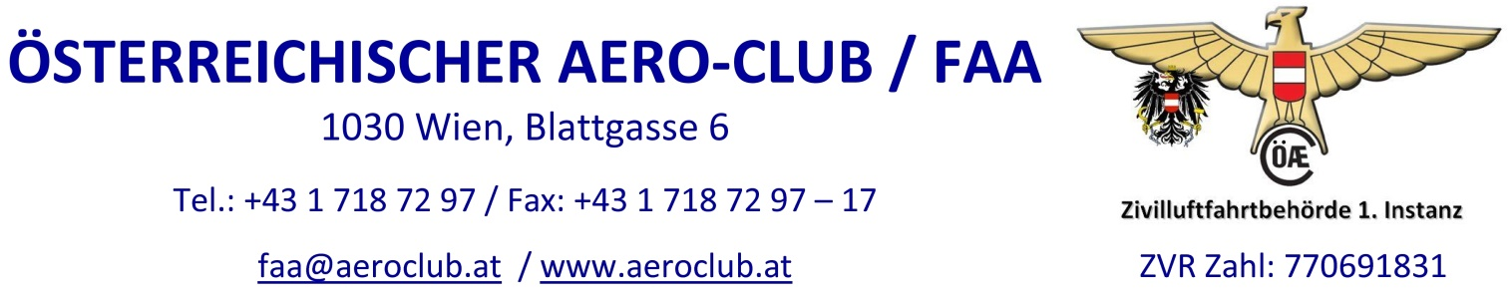

Application for approval to operate a model aircraft
With a maximum flight mass of more than 25 kg up to and including 150 kg
according to § 24c (3) LFG 1957 idgF
on the basis of a foreign approval/permit

Personal data of the applicant

Name |  |  |  |  | Surname
Date of birth |  |  |  |  | Place of birth
Nationality |  |  |  |  | Profession
Adress
 |  | State, ZIP, City, Street
E-Mail |  |  |  |  | Phone

Data of model aircraft

Make / Model
S/N |  |  |  |  |  | Max. flight mass | kg
 |  |  | Self made |  | Ready to fly

Type of model: Fixed wing /S Rotorcraft /R Balloon /B Airship /L

Impulsion: without Combustion Electric drive others

Piston engine Turbine Impeller others

Required documents (acc. to Airworthiness-Note LTH_OeAeC_MFT-01), attached to the application:

Three side view of the model aircraft indicating main dimensions and photo

Proof of identity (Copy of ID or passport)

Foreign approval/permit

If for authorization necessary, further documents will be submitted on request of the authority.

Place and date
Signature of applicant

Charges: TP20A administrative charge (link to Gebührenordnung)
€ 14,30 fixed charge + postage

Information: An invoice referring to Austrian law and tarif of the Austrian Aero-Club will be sent with licence validation.

